**Introduction to Mobile Application**

**Development**

Name : Asitha Kanchana Palliyaguru

S Number : S23010526

Report Submission Date : 2024/11/17

LAB Report - WE

**EEI3269**

Scenario 6 : Health And Safety

Application Name that I picked : Health Mate

1. Mind Map

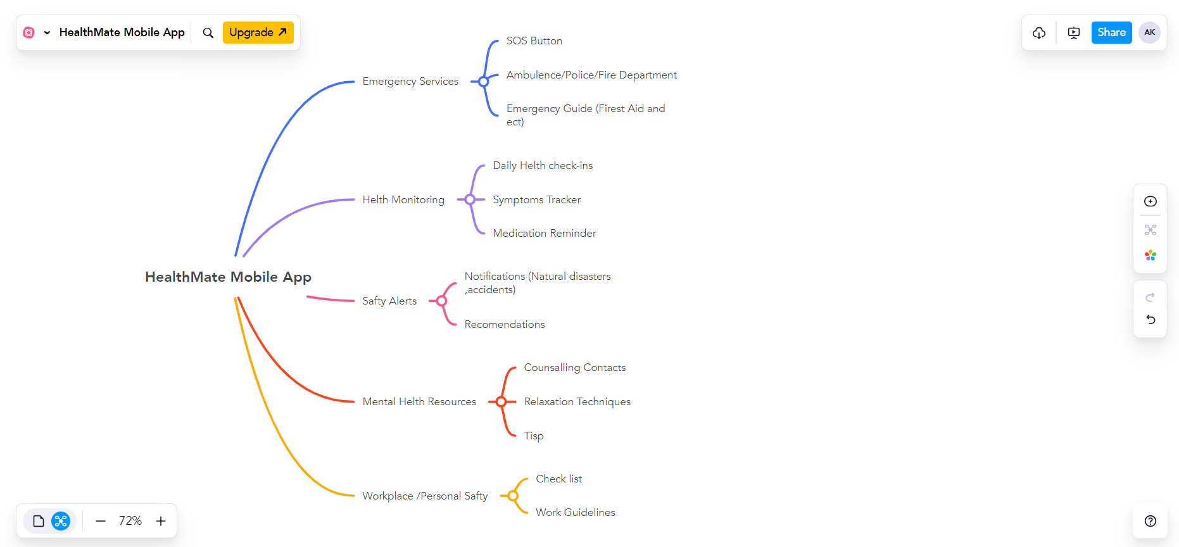

Mind Map Link : <https://mm.tt/app/map/3514918076?t=WIFncoQZuX>



Our Health and Safety app Health Mate uses real-time sentiment analysis and location data to adapt to user needs. By analyzing user input like text or voice, the app identifies emotional states (example: stress or anxiety) for example if user type text unusual hurry then we can help them by asking them if thay need emergency contacts or other emergency features and we can recommends tailored features like relaxation exercises or mental health resources. Additionally, location-based notifications provide personalized safety alerts, such as nearby health risks or weather warnings. This real-time adaptability creates an engaging and user-friendly experience, ensuring the app is relevant to the user's current context and emotional state. AI and machine learning enhance personalization, enabling predictive recommendations based on historical usage data.



Figma Wire Frame Link : <https://www.figma.com/design/EPGTxhYV08PapicJlnuVRB/S23010526_LAB_3269_WE?node-id=0-1&t=vH9Zc1uIO1AfsLJA-1>

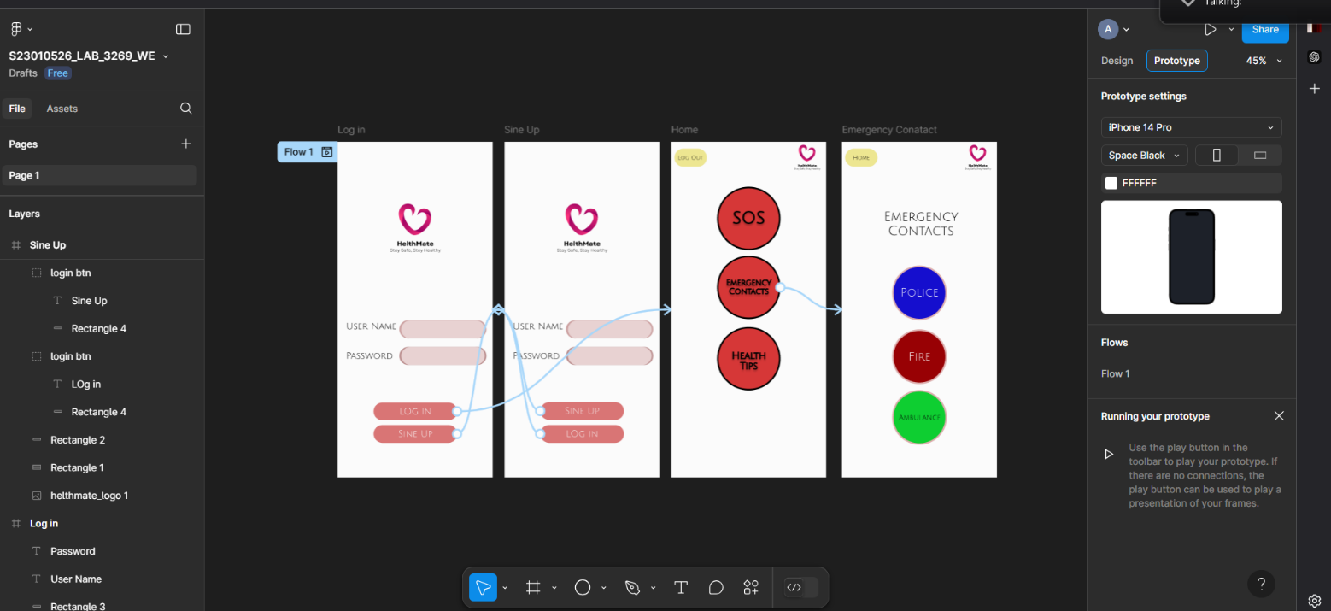

1. Creating React Native App

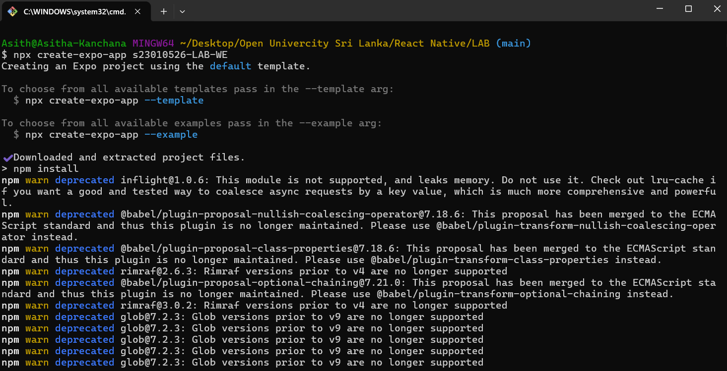

Clarification : I have Mostly Used Last Designer Report 4 Code for this Project Because time is limited so most of the parts are already I have researched

Two UI

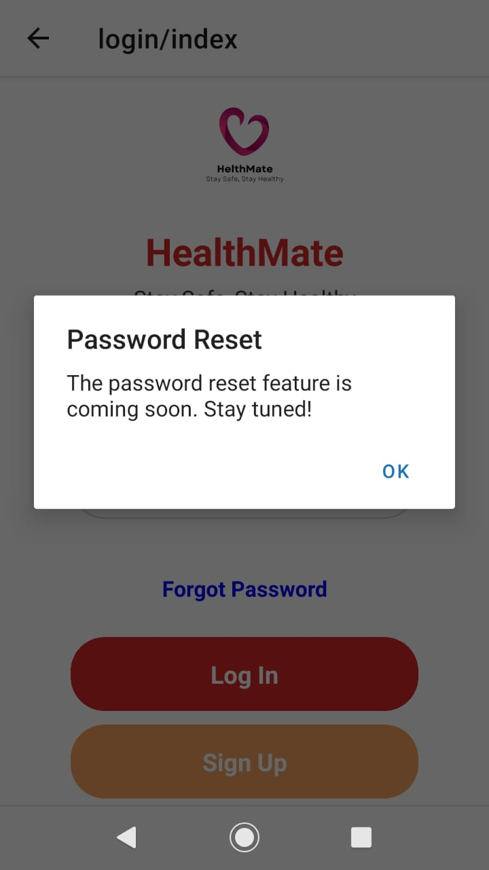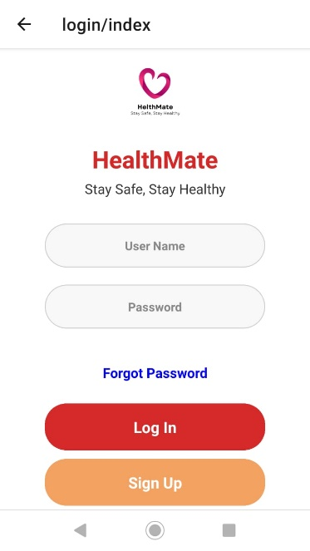Loging Page

Code :

// for routering

import { router } from "expo-router";

import { StatusBar } from "expo-status-bar";

// Main Packages

import { StyleSheet, Text, View, Image, TextInput, TouchableOpacity } from "react-native";

// to add Alert tofogot password

import { Alert } from 'react-native';

export default function App() {

  return (

    <View style={styles.container}>

{/* statusbar confg */}

      <StatusBar style="dark" hidden={true} />

      {/* Logo/Title installment */}

      <View style={styles.logoContainer}>

        <Image

          source={require('../../assets/images/helthmate_logo.png')} //logo location path

          style={styles.logoImage}

        />

        {/* app name*/}

        <Text style={styles.title}>HealthMate</Text>

        {/* app slogen */}

        <Text style={styles.subtitle}>Stay Safe, Stay Healthy</Text>

      </View>

      {/* Username Input */}

      <TextInput

        style={styles.input}

        placeholder="User Name"

        placeholderTextColor="#888" //almost transparent background color for txt_input

      />

      {/* Password Input */}

      <TextInput

        style={styles.input}

        placeholder="Password"

        placeholderTextColor="#888"//almost transparent background color for txt_input

        secureTextEntry={true}

      />

      {/* Buttons */}

      <View style={styles.buttonContainer}>

        {/* fogot password */}

        {/* still i havent implimented fogot pass option so this is place holder for that */}

      <TouchableOpacity onPress={() => Alert.alert("Password Reset", "The password reset feature is coming soon. Stay tuned!")} style={styles.loginBtnFogot}>

             <Text style={styles.btnTextFogot}>Forgot Password</Text>

        </TouchableOpacity>

{/* Loging button */}

{/* ihave used navigation by using router.push it is eseir than other method */}

        <TouchableOpacity onPress={() => router.push('/home')} style={styles.loginBtn}>

          <Text style={styles.btnText}>Log In</Text>

        </TouchableOpacity>

        {/* sine up button */}

        <TouchableOpacity onPress={() => router.push('/sinup')} style={styles.signupBtn}>

          <Text style={styles.btnText}>Sign Up</Text>

        </TouchableOpacity>

      </View>

    </View>

  );

}

const styles = StyleSheet.create({

  // Container styles

  container: {

    flex: 1,

    backgroundColor: '#fff',

    alignItems: 'center',

    paddingHorizontal: 20,

    justifyContent: 'center',

  },

  // Logo container styles

  logoContainer: {

    alignItems: 'center',

    marginBottom: 30,

  },

  // Logo image styles

  logoImage: {

    width: 100,

    height: 100,

  },

  // Titletext styles

  title: {

    fontSize: 28,

    fontWeight: 'bold',

    color: '#d62828', // HealthMate's primary red color

    marginTop: 10,

  },

  // slogen styling

  subtitle: {

    fontSize: 16,

    color: '#333',

    marginTop: 5,

  },

  // Input fields (most of styles are previus Disigner repot 4 )

  input: {

    borderRadius: 30,

    width: "80%",

    backgroundColor: '#f8f8f8', //light color bg

    padding: 15,

    marginBottom: 20,

    textAlign: 'center',

    fontWeight: 'bold',

    borderColor: '#ccc',

    borderWidth: 1,

  },

  // Login button styles

  loginBtn: {

    borderRadius: 25,

    backgroundColor: '#d62828', // Hred color background it is light red

    padding: 15,

    width: "100%",

    marginBottom: 10,

  },

  loginBtnFogot: {

    borderRadius: 10,

    padding: 15,

    width: "100%",

    marginBottom: 10,

  },

  // Sign Up button

  signupBtn: {

    borderRadius: 25,

    backgroundColor: '#f4a261', // light orange color

    padding: 15,

    width: "100%",

  },

  // Button text

  btnText: {

    fontSize: 18,

    textAlign: 'center',

    fontWeight: 'bold',

    color: 'white',

  },

  btnTextFogot: {

    fontSize: 16,

    textAlign: 'center',

    fontWeight: 'bold',

    color: 'blue',

  },

  // Button container

  buttonContainer: {

    width: "80%",

    marginVertical: 5,

  },

});

Home Page

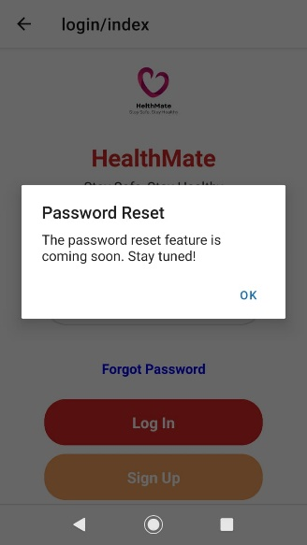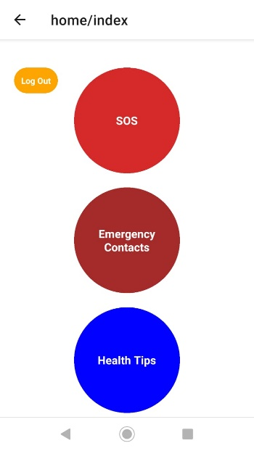

import React from "react";

import { View, Text, StyleSheet, TouchableOpacity, Alert, ScrollView } from "react-native";

import { router } from "expo-router";

// Alert Box

const HomeScreen = () => {

  const handleLogOut = () => {

    Alert.alert(

      "Logging Out",

      "Are you sure you want to Log Out?",

      [

        {

          text: "Yes",

          onPress: () => {

            console.log("Logged Out");

            router.push('/login'); // Navigate to login screen after logging out

          },

        },

        { text: "No", onPress: () => console.log("Cancel Log Out") },

      ]

    );

  };

  return (

    <View style={styles.container}>

      {/* Log Out Button */}

      <TouchableOpacity style={styles.logOutBtn} onPress={handleLogOut}>

        <Text style={styles.logOutText}>Log Out</Text>

      </TouchableOpacity>

      {/* Scrollable Content */}

      <ScrollView

        contentContainerStyle={styles.scrollContainer} // content alignment update

        showsVerticalScrollIndicator={false} // scroll indicator hide

      >

        {/* SOS Button nav */}

        <TouchableOpacity

          style={styles.sosButton}

          onPress={() => Alert.alert("SOS Activated")} // alart ekak eawa

        >

          <Text style={styles.btnText}>SOS</Text>

        </TouchableOpacity>

        {/* Emergency Contacts Button nav */}

        <TouchableOpacity

          style={styles.emergencyContactsButton}

          onPress={() => router.push("/emergency-contacts")}

        >

          <Text style={styles.btnText}>Emergency{`\n`}Contacts</Text>

        </TouchableOpacity>

        {/* Health Tips Button */}

        <TouchableOpacity

          style={styles.healthTipsButton}

          // page eka haduwe na

          onPress={() => Alert.alert("Health Tips Coming Soon!")}

        >

          <Text style={styles.btnText}>Health Tips</Text>

        </TouchableOpacity>

      </ScrollView>

    </View>

  );

};

const styles = StyleSheet.create({

  container: {

    flex: 1,

    backgroundColor: "white", // bg color update

  },

  scrollContainer: {

    flexGrow: 1,

    alignItems: "center",

    justifyContent: "center",

    paddingVertical: 20, //padding page

  },

  logOutBtn: {

    position: "absolute",

    top: 40,

    left: 20,

    backgroundColor: "orange",

    padding: 10,

    borderRadius: 20,

    zIndex: 1, // stay in all button above

  },

  logOutText: {

    color: "white",

    fontWeight: "bold",

    fontSize: 12,

  },

  sosButton: {

    marginTop: 20,

    width: 150,

    height: 150,

    borderRadius: 75,

    backgroundColor: "#d62828", // Red for SOS

    justifyContent: "center",

    alignItems: "center",

    marginBottom: 20,

  },

  emergencyContactsButton: {

    width: 150,

    height: 150,

    borderRadius: 75,

    backgroundColor: "brown",

    justifyContent: "center",

    alignItems: "center",

    marginBottom: 20,

  },

  healthTipsButton: {

    width: 150,

    height: 150,

    borderRadius: 75,

    backgroundColor: "blue",

    justifyContent: "center",

    alignItems: "center",

  },

  btnText: {

    color: "white",

    fontSize: 16,

    fontWeight: "bold",

    textAlign: "center",

  },

});

export default HomeScreen;